**TERMS OF REFERENCE**

**Expert in Green Recovery to facilitate the monitoring of the Ukraine Plan implementation at the Ministry of Environmental Protection and Natural Resources of Ukraine**

**(Category 2)**

**1.** **Objective(s) and linkages to reforms**

The Recovery and Reform Support Team (**RST**) at the Ministry of Environmental Protection and Natural Resources of Ukraine (**Ministry**) is a group of Ukrainian professionals (non-civil servants) funded on a temporary basis through the Ukraine Recovery and Reform Architecture (**URA**) [1] programme that provides targeted technical support and assists the Ministry in the design and implementation of priority reforms. The RST will assist in filling capacity gaps in the design and implementation of priority reform strategies and programmes, while strengthening links and partnerships between the Ministry’s priorities and relevant donor support.

The Ministry of Economy (**MinEconomy**) is the designated National Coordinator for the Ukraine Plan. The National Coordinator’s Team (**NCT**) will oversee the monitoring of the Ukraine Plan, supported by the newly established Subdivision on Coordination of Ukraine Plan Implementation within MinEconomy. This Subdivision will comprise nine civil servants and be reinforced by a new sub-unit within the MinEconomy RST, which will aid in coordinating reforms in alignment with the EU Commission's annual Enlargement Reports on Ukraine, the Ukraine Plan[2] implementation, Ukraine Facility Regulation #2024/792, the Framework Agreement between the EU and Ukraine on specific arrangements for the implementation of Union funding under the Ukraine Facility, and key strategic documents of the Government of Ukraine.

The NCT will include relevant departments from line ministries, supported by the RST teams in these ministries and the Reform Delivery Office (RDO). All RSTs and the RDO are expected to assist MinEconomy’s staff in coordinating and monitoring the Ukraine Plan in collaboration with other line ministries and partners.

The sub-unit within the MinEconomy RST will serve as the main liaison for all RSTs, consolidating expertise and insights from line ministries and their reform support teams. Within the MinEconomy RST, a Deputy Director – Special Representative for Ukraine Plan Coordination and Monitoring (SEUP) will be appointed. The RST of the Ministry of Environmental Protection and Natural Resources of Ukraine must closely coordinate with the SEUP, who will act as the main focal point for all RSTs, necessitating close collaboration with MinEconomy’s focal point.

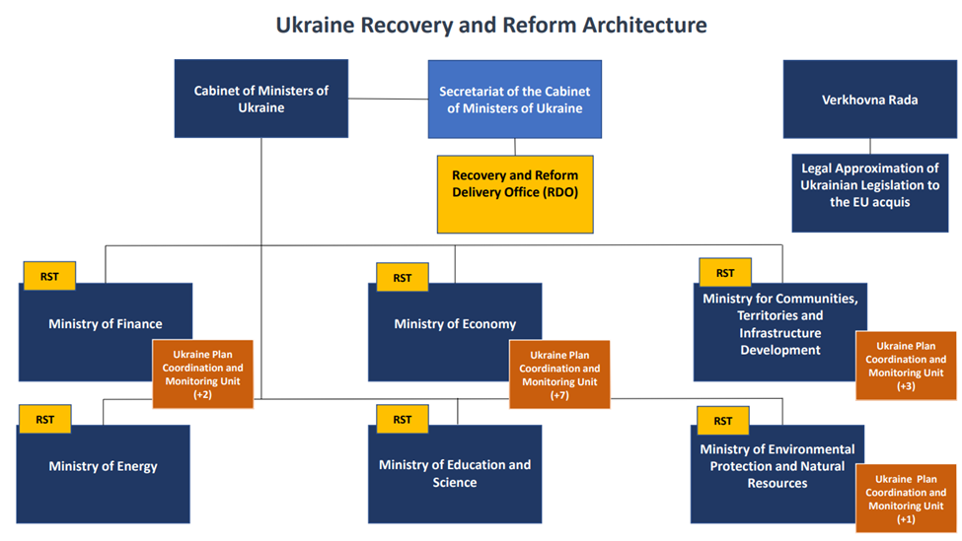

The Expert (Green Recovery) is expected to support the implementation of the cross-cutting aspect of applying environmental green recovery principles as an experienced expert in assessments and report development in accordance with Ukrainian and international standards to help facilitate the implementation and monitoring of the Ukraine Plan.

**2. Position and reporting line**

The Expert will be a full-time consultant at the RST at the Ministry. The consultant is expected to be based in Kyiv (subject to the Ministry's staff's security rules).

The Expert will be subordinated to the Director of the RST at the Ministry of Environmental Protection and Natural Resources of Ukraine but will be in close contact with the RST of the MinEconomy, specifically with the SEUP, and the MinEconomy as the National Coordinator of Ukraine Plan. In a broader sense, the Expert will be part of the National Coordinator’s Team working on Ukraine Plan Coordination and Monitoring.

**3. Duration and proposed timeframe**

The initial consultancy assignment is expected to start in July 2024 and has an estimated duration till August 2025. The assignment may be subsequently continued subject to the availability of funding, the consultant’s performance, and the specific needs of the RST. The probation period is three months.

**4.** **Main duties and responsibilities**

The Expert is expected to assist in the following

* Support in coordination and facilitation of RST activities pertaining to the environmental sphere of the Ukraine Plan;
* Assisting in fostering engagement and cooperation with relevant stakeholders (primarily MinEconomy and other line ministries officials, national and sub-national government bodies, business community stakeholders’ sovereign borrowers, as well as the European monitoring and control bodies, such as the European Commission, OLAF, ECA, EPPO, as well as other relevant donors, IFIs, and other relevant counterparts) concerning issues of the Ukraine Facility and Ukraine Plan implementation;
* Support environmental recovery processes and expedited alignment with the European Green Deal as envisaged by the Ukraine Plan, Ukraine Facility Regulation No 2024/792 (**Regulation**), and the Framework Agreement between the EU and Ukraine;
* Providing an assessment of the implementation of the Ukraine Plan's green agenda and the required European Union principles as defined by the Regulation.
* Participating in joint working groups, meetings, and discussions with the Ministry, the MinEconomy, business, and other stakeholders related to the assignment.
* Helping prepare monitoring reports (annual, monthly, and weekly);
* Collecting data to assisting with forecast/analysis of potential scenarios of events and developing recommendations for response.

**Expected deliverables**

The Expert will be expected to provide the following deliverables:

* Regular (be-weekly or monthly as agreed by the National Coordinator) monitoring progress reports in accordance with the indicators and timelines set in the business environment and key sectors chapters of the Ukraine Plan for the Head of the National Coordinator Sub-Division, the Deputy Minister of Economy, the RST Director, the SEUP, and other stakeholders as assigned;
* Regular updates of data tables and charts for ongoing analysis of implementation risks and tracking progress of activities implementation for the Head of the National Coordinator Sub-Division, the Deputy Minister of Economy, and the RST Director, the SEUP, and other stakeholders as assigned;
* Ad-hoc reports on progress towards upcoming steps for the Ukraine Plan implementation and the Ukraine Facility provision implementation for the Head of the National Coordinator Sub-Division, the Deputy Minister of Economy, the RST Director, the SEUP and other stakeholders as assigned.
* Data presentations in the form of slide decks, infographics, and analytical tables/graphs in support of necessary reporting information;
* Quarterly internal reports on RST progress, challenges and achievements withing the sphere of environmental policy of the Ukraine Plan.

The specified lists of scope of work, services and expected deliverables can be modified and supplemented on request from the Ministry and the MinEconomy.

**5. Qualifications, skills and experience**

**5.1 Qualifications and skills**:

* Master’s degree in Environmental Sciences, Public Administration, Economics, Law, Management, Public Policy or other related fields;
* Strong analytical, communication, and presentation skills.
* Excellent verbal, written, and communication skills.
* Advanced level of PC literacy (PowerPoint, Project, Excel, Word).
* Fluency in Ukrainian and English.
* Good inter-personal skills.

**5.2 Professional experience:**

Minimum of 5 years of general professional experience of which:

* at least 3 years of experience in environmental protection and management and/or sustainable management.

**5.3 Other competencies:**

* Excellent knowledge of Ukrainian, EU and relevant international legislation, conventions, and standards pertaining to environmental protection and management.
* Previous experience working for international companies/organisations.
* Relevant professional experience in IFI will be an asset.
* Familiarity with Ukraine’s current reform agenda, and a good understanding of policy formulation processes and policy dialogues.

**6. Funding Source**

The funding source of this assignment is the EBRD Ukraine Stabilisation and Sustainable Growth Multi-Donor Account (MDA). Contributors to the MDA are Austria, Denmark, Finland, France, Germany, Italy, Japan, Latvia, the Netherlands, Norway, Poland, Sweden, Switzerland, the United Kingdom, the United States and the European Union, the largest donor.

Please note that selection and contracting will be subject to the availability of funding.

**7. Submissions**

Submissions must be prepared in English only and be delivered electronically by 7 July 2024, 23:59 (Kyiv time) to _____. All submissions must include a completed Application form, NDA Form, the candidate’s Curriculum Vitae and contact details for three referees who, if contacted, can attest to the professional and/or educational background of the candidate.

Only applications that have been submitted using the correct template and are fully completed will be considered.

**Important notice: only Ukrainian nationals are eligible to apply; civil servants are not eligible to apply unless 6 months have elapsed since they left such employment.**

**8.** **Selection Procedure**

Following the evaluation of all applications received, selected candidates may be invited to a written test. Only shortlisted candidates will be invited to the interview.

1. Ukraine Recovery and Reform Architecture (URA) is a comprehensive technical assistance programme deployed by the European Bank for Reconstruction and Development (EBRD), in partnership with the European Union, to support critical recovery and reform processes in Ukraine. URA is financed from the Ukraine Stabilisation and Sustainable Growth Multi-Donor Account (MDA) managed by the EBRD.
2. <https://www.ukrainefacility.me.gov.ua/>