**TERMS OF REFERENCE**

**Senior Project Manager (Business environment & priority sectors reforms**)

**at the Ministry of Economy of Ukraine**

**(Category 1)**

**1.** **Objective(s) and linkages to reforms**

The Recovery and Reform Support Team (**RST**) at the Ministry of Economy of Ukraine (**Ministry**) is a group of Ukrainian professionals (non-civil servants) funded on a temporary basis through the Ukraine Recovery and Reform Architecture (URA)[1] programme that provides targeted technical support and assists the Ministry in the design and implementation of priority reforms. The RST will assist in filling capacity gaps in the design and implementation of priority reform strategies and programmes, while strengthening links and partnerships between the Ministry’s priorities and relevant donor support.

The Ministry of Economy (**MinEconomy**) is the designated National Coordinator for the Ukraine Plan. The National Coordinator’s Team (**NCT**) will oversee the monitoring of the Ukraine Plan, supported by the newly established Subdivision on Coordination of Ukraine Plan Implementation within MinEconomy. This Subdivision will comprise nine civil servants and be reinforced by a new sub-unit within the MinEconomy RST, which will aid in coordinating reforms in alignment with the EU Commission's annual Enlargement Reports on Ukraine, the Ukraine Plan[2] implementation, Ukraine Facility Regulation #2024/792, the Framework Agreement between the EU and Ukraine on specific arrangements for the implementation of Union funding under the Ukraine Facility, and key strategic documents of the Government of Ukraine.

The NCT will include relevant departments from line ministries, supported by the RST teams in these ministries and the Reform Delivery Office (**RDO**). All RSTs and the RDO are expected to assist MinEconomy’s staff in coordinating and monitoring the Ukraine Plan in collaboration with other line ministries and partners.

The sub-unit within the MinEconomy RST will serve as the main liaison for all RSTs, consolidating expertise and insights from line ministries and their reform support teams. Within the MinEconomy RST, a Deputy Director – Special Representative for Ukraine Plan Coordination and Monitoring (**SEUP**) will be appointed.

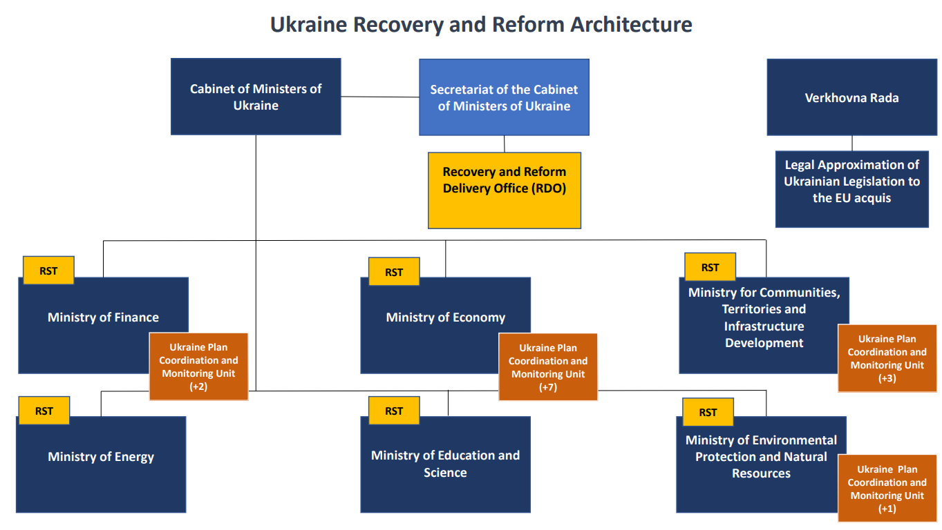

The Senior Project Manager (Business environment & priority sectors) (SPM) is expected to support the implementation, monitoring and control activities for the business environment & key priority sectors of the Ukraine Plan. The assignment will include analytical work with large datasets of information, assisting MoE in preparing various reports, analytical papers, reviews and analysis of legislation, drafts legislative acts, as well as stakeholder management. The SPM is also expected to be a capable team player, able to assist in building coordination networks among colleagues from other government agencies and ministries and the Reform Delivery Office of the Cabinet of Ministers (RDO) team.

**2. Position and reporting line**

The SPM will be a full-time consultant at the RST at the Ministry. The consultant is expected to be based in Kyiv (subject to the Ministry's staff's security rules).

The SPM will be subordinated to the Director of the RST at the Ministry of Economy of Ukraine and the Deputy Head of RST - Special Representative for Ukraine Plan Coordination and Monitoring (SEUP). At the same time, RST Director is tasked with a broader scope of issues than the ones solely connected to the Ukraine Plan whereas the SEUP will be focusing on all the work pertaining to the Ukraine Plan implementation, coordination and monitoring, being the key liaison point within the whole URA system. Thus, the SPM will be subordinated to the SEUP in his/her operational activity and to the RST Director in terms of general subordination to a person heading the RST. In a broader sense, SPM will be part of the National Coordinator’s Team working on Ukraine Plan Coordination and Monitoring.

**3. Duration and proposed timeframe**

The initial consultancy assignment is expected to start in July 2024 and has an estimated duration till August 2025. The assignment may be subsequently continued subject to the availability of funding, the consultant’s performance, and the specific needs of the RST. The probation period is three months.

**4.** **Main duties and responsibilities**

The SPM is expected to provide support to the National Coordinator (the MoE) in coordination and facilitation of RST activities related to implementation, monitoring and control of business environment improvements and reforms of the key sectors as foreseen by the relevant chapter of the Ukraine Plan. The SPM is expected to assist in the following.

* Assisting in fostering engagement and cooperation with relevant stakeholders (primarily the Ministry and other line ministries officials, national and sub-national government bodies, business community stakeholders sovereign borrowers, as well as the European monitoring and control bodies, such as the European Commission, OLAF, ECA, EPPO, as well as other relevant donors, IFIs, and other relevant counterparts) concerning issues of the Ukraine Facility and Ukraine Plan implementation;
* Assisting in resolution of problems and obstacles encountered during implementation, identification and communication of issues pertaining to the coordination and monitoring of the Ukraine Plan
* Providing project management support (support in development of project/business environment reforms implementation plan, risk management, change management, etc.);
* Contributing to coordination of preparation of timely and quality monitoring reports and status updates on business environment reform and key sectors reforms implementation progress to the SEUP,the RST Director, and other stakeholders as assigned as well as for publication.
* Contributing to the development of policies related to the development and approval of reforms for the business climate improvement and economic growth.
* Facilitating a comprehensive assessment of the state of implementation and progress of the related sectoral reforms;
* Strengthening the project management capacity by improving the legal and operational framework and establishing better collaboration between the MinEcomony, line ministries, IFIs, and EU;
* Participating in joint working groups, meetings, and discussions with the reform stakeholders
* Organising and ensuring quality of research, collection and analysis of data from various sources in order to provide necessary reporting information.
* Coordinating the creation of matrices with tracking the implementation of indicators in accordance with the Ukraine Plan,
* Quality control of the creation of slide decks and the implementation of tools for automatic data collection.
* Assisting with forecasting/analysis of potential scenarios of events and developing recommendations for response.

**Expected deliverables**

The SPM will be expected to provide the following deliverables:

* Regular (be-weekly or monthly as agreed by the National Coordinator) monitoring progress reports in accordance with the indicators and timelines set in the business environment and key sectors chapters of the of the Ukraine Plan for the Head of the National Coordinator Division, the Deputy Minister of Economy, the SEUP, the RST Director and other stakeholders as assigned; Regular updates of data tables and charts for ongoing analysis of implementation risks and tracking progress of activities implementation for the Head of the National Coordinator Division, the Deputy Minister of Economy, and the SEUP, the RST Director and other stakeholders as assigned;
* Ad-hoc reports on progress towards upcoming steps for the Ukraine Plan implementation and the Ukraine Facility provision implementation for the Head of the National Coordinator Division, the Deputy Minister of Economy, the SEUP, the RST Director, the RDO Director, and other stakeholders as assigned.
* ⁠Data presentations in the form of slide decks, infographics, and analytical tables/graphs in support of necessary reporting information;
* Quarterly internal reports on RST progress on the coordination and monitoring of Ukraine Plan implementation, challenges and achievements in this process.

The specified lists of scope of work, services and expected deliverables can be modified and supplemented on request from the Ministry.

**5. Qualifications, skills and experience**

**5.1 Qualifications and skills**:

* Master’s degree in Economics, Finance, Law, Management, Public Policy or other related fields;
* Strong analytical research and data processing skills;
* Excellent communication and presentation skills;
* Advanced level of PC literacy (PowerPoint, Project, Excel, Word);
* Excellent command of Ukrainian and fluency in English.

**5.2 Professional knowledge and experience:**

* Minimum of 7 years of general professional experience of which:
* at least 5 years of proven experience in economic policy development and/or project management, public or business administration, or consulting (related to the field of the assignment); and
* at least 2 years of proven analytical experience.
* Experience working for international organisations, notably International Financial Institutions, and/or international technical assistance projects would be an advantage.
* Familiarity with Ukraine’s current reform agenda, and a good understanding of policy formulation processes and policy dialogues.

**6. Funding Source**

The funding source of this assignment is the EBRD Ukraine Stabilisation and Sustainable Growth Multi-Donor Account (MDA). Contributors to the MDA are Austria, Denmark, Finland, France, Germany, Italy, Japan, Latvia, the Netherlands, Norway, Poland, Sweden, Switzerland, the United Kingdom, the United States and the European Union, the largest donor.

Please note that selection and contracting will be subject to the availability of funding.

**7. Submissions**

Submissions must be prepared in English only and be delivered electronically by 29 October, 23:59 (Kyiv time) to [rstrecruiting2017@gmail.com](mailto:rstrecruiting2017@gmail.com). All submissions must include a completed [Application form](https://docs.google.com/document/d/1iFvdLaQ2-HoJ6dqx_Xyro9teDWmJnvlp/edit?usp=sharing&ouid=116511142743250443349&rtpof=true&sd=true), [NDA Form](https://docs.google.com/document/d/1nZR7uhfufOwYJE5O8TXsJ-qPFwRwfi-N/edit#heading=h.gjdgxs), the candidate’s Curriculum Vitae and contact details for three referees who, if contacted, can attest to the professional and/or educational background of the candidate.

Only applications which have been submitted using the correct template and are fully completed will be considered.

**Important notice: only Ukrainian nationals are eligible to apply; civil servants are not eligible to apply unless 6 months have elapsed since they left such employment.**

**8.** **Selection Procedure**

Following the evaluation of all applications received, selected candidates may be invited to a written test. Only shortlisted candidates will be invited to the interview.

1. Ukraine Recovery and Reform Architecture (URA) is a comprehensive technical assistance programme deployed by the European Bank for Reconstruction and Development (EBRD), in partnership with the European Union, to support critical recovery and reform processes in Ukraine. URA is financed from the Ukraine Stabilisation and Sustainable Growth Multi-Donor Account (MDA) managed by the EBRD.
2. <https://www.ukrainefacility.me.gov.ua/>